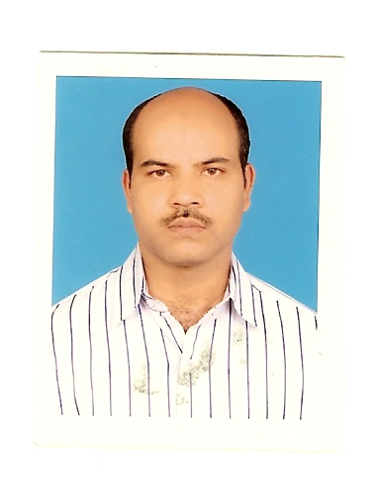

CONGRATULATION

Shri Shiv Kumar, TGT (S.St), Kendriya Vidyalaya No.2, Srinagar has been selected in Civil Services Examination 2007 and achieved 57th rank.

