Achievements of KVS in ThinkQuest Global Competition 2009

A team of KV students has won a place of distinction by winning “Honorable Mention” in the educational website building competition conducted by Oracle Education Initiatives. Website “Flying Jewels” has made it to the Honorable Mention category. Through this website the team has succeeded in bringing out a subtle environmental change occurring slowly – a gradual extinction of butterflies. Butterflies play an important role in the environment and their extinction will produce profound impact on the environment.

Ms. Harminder Kaur Suri, KV No. 1 Ambala Cantt, jointly mentored this team. as Lead Coach and Mr. Ashok Sen Gupta, PGT(Comp. Sci.) has Assistant Coach.

Following students formed the team :-

- Ms. Bhawna, Class IX from KV No. 1 Ambala Cantt.
- Master Harsh, Class IX from KV No. 1 Jalahalli
- Ms. Parinita, Class IX from KV No. 1 Jalahalli
- Ms Sumita, Class IX from KV Maligaon
- Ms Manisha, Class IX from KV No. 1 Ambala Cantt.

KVS is proud of teachers like Ms. Harminder Kaur Suri and Mr. Ashok Sen Gupta and above students for winning such a prestigious place in a global competition. Congratulation to each one of them.
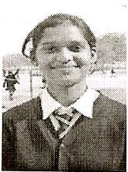 Bhawna IX, KV No.1, Ambala Cantt., Haryana
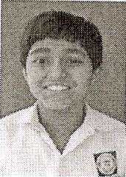 Harsh IX, KV No. 1 , Jalahalli , Bangalore
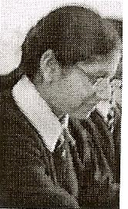 Manisha IX, KV No.1, Ambala Cantt., Haryana

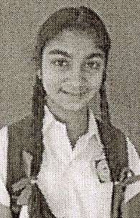 Parinita IX, KV No.1, Jalahalli, Bangalore
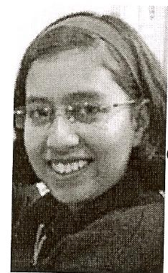 Sumita IX, KV Maligaon, Guwahati

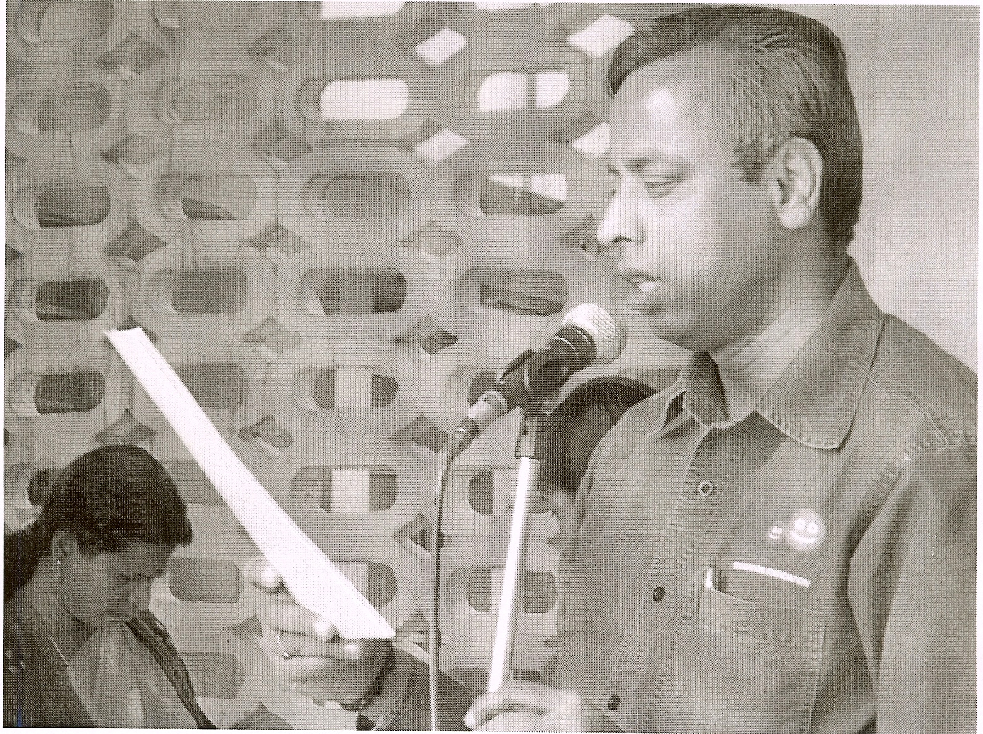 Mr. Ashok Sen Gupta, PGT(Comp.Sci.)

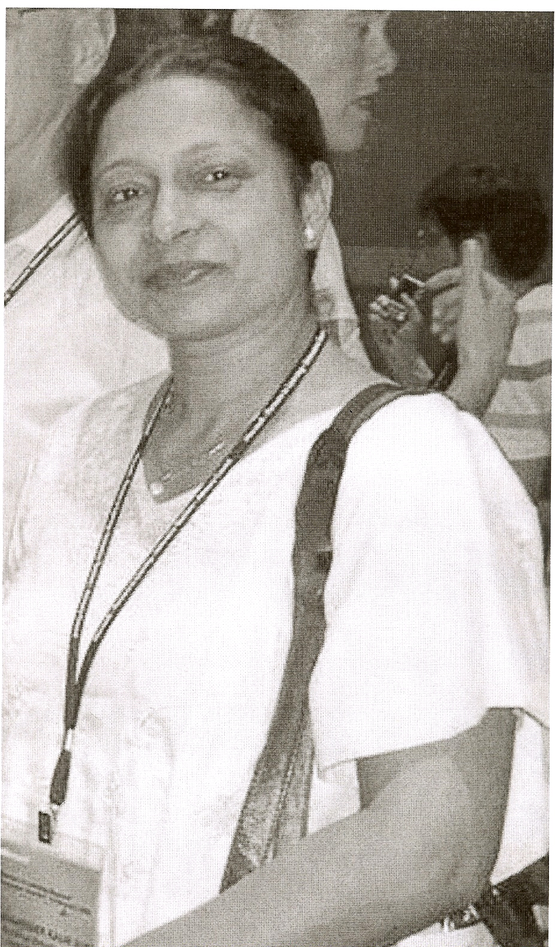 Ms. Harminder Kaur Suri, KV No.1, Ambala Cantt.

